A Real-Time (or) Field-based Research Project Report
on
REMOTE OPERATED METAL DETECTING ROBOT

submitted in partial fulfillment of the requirements for the award of the
degree
of
Bachelor of Technology
in
COMPUTER SCIENCE AND ENGINEERING
by
P.BHAVANI PRIYA[227R1A05Q1]
V.NITHIN [227R1A05R1]
M.SUHAN [237R5A0526]
Under the guidance of

Dr. B.LAXMAIAH
Associate professor
r 
DEPARTMENT OF COMPUTER SCIENCE AND ENGINEERING
CMR TECHNICAL CAMPUS
UGC AUTONOMOUS
Accredited by NBA & NAAC with ‘A’ Grade
Approved by AICTE, New Delhi and JNTUH Hyderabad
Kandlakoya (V), Medchal Road, Hyderabad - 501401
December, 2023

DEPARTMENT OF COMPUTER SCIENCE AND ENGINEERING

CERTIFICATE

This is to certify that the Real-Time (or) Field-based Research Project Report entitled“REMOTE OPERATED METAL DETECTING ROBOT” being submitted by P.BHAVANI(227R1A05Q1),V.NITHIN(227R1A05R1)M.SUHAN(237R5A0526) inpartial fulfillment of the requirements for the award of the degree of Bachelor of Technology inCOMPUTER SCIENCE AND ENGINEERING to the Jawaharlal Nehru TechnologicalUniversity, Hyderabad is a record of bonafide work carried out by them under my guidance andsupervision during the Academic Year 2023 – 24.

The results embodied in this thesis have not been submitted to any other University or
Institute for the award of any other degree or diploma.

< Signature of the Supervisor> < Signature of the HOD>
Dr.B.Laxmaiah Dr. K. Srujan Raju
Associate proffesor Head of the Department

< Signature of the Director>
Dr. A. Raji Reddy
Director

ABSTRACT

This paper introduces a remote-operated metal detecting robot designed for various applications such as exploration and inspection tasks in diverse environments. The robot integrates the functionalities of mobility, metal detection, and remote operation, offering a comprehensive solution for scenarios where human intervention is challenging or risky.Remote operation is facilitated through wireless communication protocols, allowing operators to control the robot from a safe distance. The control interface provides real-time feedback on the robot's position, detected objects, and sensor data, enabling operators to make informed decisions during exploration or inspection missions.The versatility of the robot makes it suitable for a wide range of applications,Its ability to navigate challenging terrains and detect metal objects efficiently enhances productivity and safety in various fields. The development of a remote operated metal detecting robot represents a significant advancement in the fields of archaeology, security, and landmine detection. This technology integrates robotic mobility with advanced metal detection capabilities, enabling efficient and safe exploration of environments that may be hazardous or difficult for humans to access.Primarily, it aims to enhance safety and security by swiftly detecting metallic objects, ranging from weapons to hazardous materials, thereby mitigating potential risks in environments such as airports, military zones, or disaster areas.

TABLE OF CONTENTS

S.NO NAME OF CONTENT

1 Introduction

2 Literature survey

3 Analysis & design

3.1 Design

3.2 Analysis

4 Experimental Investigations

4.1 Methodology

5 Implementation

6 Testing and Debugging/Results

7 Conclusion

8 References

- INTRODUCTION

1.INTRODUCTION

The remote operated metal detecting robot is a cutting-edge solution designed to improve safety and efficiency in metal detection tasks across various fields, including archaeology, security, and landmine detection. This sophisticated machine integrates advanced metal detection sensors with a robust, all-terrain robotic platform, allowing it to autonomously navigate and identify metal objects buried beneath the surface. Operated remotely via a user-friendly control interface, the robot provides real-time feedback to the operator, ensuring precise and thorough metal detection without exposing individuals to potential hazards. With its wireless communication capabilities, the robot can be controlled from a safe distance, making it an invaluable tool for tasks that require meticulous metal detection in challenging or dangerous environments. By combining state-of-the-art technology with practical applications, the remote operated metal detecting robot represents a significant advancement in both safety and operational efficiency.A remote-operated metal detecting robot serves as a versatile and efficient tool with multifaceted objectives across various domains.Through its remote operation capability, the robot enables operators to conduct detection tasks from a safe distance, ensuring human personnel remain out of harm's way.Robots can be utilized to complete work in perilous zones and can be used to manage troublesome instability levels in such areas. Gradually robots are becoming dynamically vital for standard subject applications, for instance, Urban Hunt and Salvage and military applications. A variety of small robotic applications now arising where robots are utilized to complete an assortment of errands. By and large, robots are still utilized for unsafe work which is dangerous for humans,

- LITERATURE SURVEY

2.LITERATURE SURVEY

S.No. | Name of Author | Title of the paper | International journal/conference | Volume  No. | Issue | ISBN/  ISSN | Indexing
1. | Joonseok Jung, Jongman Kwon. | HC-06 Bluetooth module | National Research Foundation of Korea(NRF) | 12 | 10,feb-2017 | ISSN: 10052197 | 1-21
2. | Potts. J and Sukittanon | Exploiting Bluetooth on Android mobile devices for home security application | ”, proceedings of  Southeastcan, Orlando, Florida, USA. | 09 | 15-18 March 2012 | E ISSN: 1558-058X  P ISSN: 1091-0050 | 24-28
3. | Piyare, R. and Tazil. | Bluetooth based home automation  system using Android phones | IEEE 15TH International symposium  on consumer electronics (ISCE). | 12 | 14-17 June 2011 | ISSN: 978-1-61284-842-6/11 | 1-7

- ANALYSIS AND DESIGN

3.ANALYSIS AND DESIGN

  - DESIGN

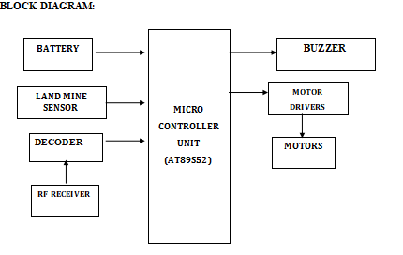

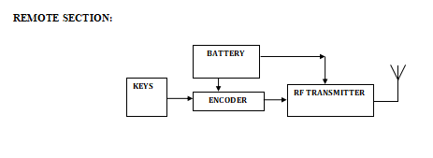

3.2.ANALYSIS

Analyzing the block diagram of a remote operated metal detecting robot involves understanding the interconnections and functions of its various components. The primary blocks typically include the metal detection unit, the robotic mobility platform, the control system, the communication module, and the power supply. Here is a detailed analysis of each component and its role within the system:

1. Metal Detection Unit
- Sensors: This block consists of advanced metal detection sensors capable of identifying different types of metals with high sensitivity. These sensors generate signals when metal objects are detected.
- Signal Processing: The raw data from the sensors are processed to filter out noise and enhance the detection accuracy. This block includes amplifiers, filters, and digital signal processors .

2. Robotic Mobility Platform
- Motors and Actuators: Responsible for moving the robot. This includes driving motors for locomotion and servos for manipulating any attached tools or sensors.
- Navigation System: Includes sensors such as gyroscopes, accelerometers, GPS, and possibly LIDAR or cameras for obstacle detection and path planning.

3. Control System
- Microcontroller/Processor: The brain of the robot, which processes input from the sensors and executes movement commands. It runs the algorithms necessary for navigation and metal detection.
- User Interface: Provides an interface for the operator to control the robot remotely. This may include a computer or a handheld device with a graphical user interface (GUI).
- Feedback Mechanisms: Displays real-time data from the sensors to the operator, including detection alerts and status updates.

4. Communication Module
- Wireless Transceiver: Ensures reliable communication between the robot and the remote control interface. Common technologies include Wi-Fi, Bluetooth, or RF communication.
- Data Encryption: To secure the data transmitted between the robot and the operator, ensuring that commands and feedback are not intercepted or tampered with.

5. Power Supply
- Battery Pack: Provides power to all the components of the robot. It needs to be efficient and have sufficient capacity to support prolonged operations.
- Power Management System: Regulates the power distribution to different modules and ensures stable operation. It may include voltage regulators, converters, and monitoring circuits.

6.Integration and Workflow
- Initialization: Upon powering up, the robot performs self-checks and initializes its sensors and communication modules.
- Operation: The operator uses the control system to maneuver the robot. The navigation system ensures the robot moves according to commands while avoiding obstacles.
- Detection: As the robot moves, the metal detection unit continuously scans the ground. Upon detecting metal, the signal processing unit confirms the presence and relays the information to the control system.
- Feedback: Detection alerts and real-time status are sent back to the operator via the communication module. The operator can then decide to investigate the detected area further or continue scanning.

4.EXPERIMENTAL INVESTIGATION

4.EXPERIMENTAL INVESTIGATION

Existing metal detecting robots, such as the Mine Kafon Drone, Land Tamer, Foerster FEREX 4.032, and Vallon VMH4, have significantly advanced the automation of locating metal objects in various fields like landmine detection, archaeological surveys, and security. These robots typically feature rugged designs and basic remote control capabilities. However, proposed remote operated metal detecting robots aim to further enhance these capabilities by integrating advanced technologies for improved performance. These new systems will feature enhanced mobility with all-terrain capabilities and sophisticated navigation systems, allowing them to operate reliably in diverse environments. They will utilize high-sensitivity metal detection sensors and advanced signal processing to increase detection accuracy. Remote operation will be facilitated through user-friendly control interfaces and real-time data transmission, providing immediate feedback on detections and robot status. Additionally, improvements in battery efficiency and power management will extend operational time. The modular design will enable easy upgrades and customization, allowing for multi-functional capabilities and broader application across different industries. These advancements will make the proposed robots more versatile, efficient, and safe compared to their existing counterparts.the proposed remote operated metal detecting robots aim to further enhance these capabilities with advanced mobility, high-sensitivity sensors, user-friendly remote operation, real-time feedback, and modular design. These improvements will expand the applications of metal detecting robots, making them more efficient, versatile, and safe for various industries and environments.
The experimental investigation of a remote operated metal detecting robot focuses on evaluating its performance, reliability, and efficiency in various conditions. The primary objective is to assess its effectiveness in detecting metal objects and navigating different terrains while being operated remotely. Detection tests are performed by remotely operating the robot to locate the buried objects, recording detection rates, false positives, and false negatives. The remote control interface's functionality is assessed for response time, ease of use, and communication reliability. Additionally, power consumption is monitored to evaluate battery efficiency. Tests are also conducted under varying environmental conditions to ensure robustness and reliability. Data is collected and analyzed to measure detection accuracy, mobility performance, and the overall efficiency of remote operation. This comprehensive investigation aims to validate the robot's capabilities and identify areas for improvement.

4.1 METHODOLOGY

- The methodology for developing a remote-operated metal detecting robot (ROMDR) involves several key steps.

- First, requirements are analyzed to determine project objectives and constraints.

- Then, conceptual designs are generated and evaluated, followed by component selection and integration.

- A prototype is developed using rapid prototyping techniques, and sensors are calibrated and tested for optimal performance.

- Mobility and navigation systems are tested, and a remote control system is developed for real-time monitoring and control.

- The integrated system undergoes comprehensive testing, including field trials to evaluate performance.

- Feedback from trials informs iterative improvements to the design.

- Documentation and reporting are conducted throughout the process, and the ROMDR is deployed for operational use, with maintenance protocols established for ongoing reliability.

5.IMPLEMENTATION

5.IMPLEMENTATION

#include <LiquidCrystal.h>
#include <stdio.h>

LiquidCrystal lcd(6, 7, 5, 4, 3, 2);

int sti=0;
String inputString = ""; // a string to hold incoming data
boolean stringComplete = false; // whether the string is complete

int m1a = 8;
int m1b = 9;
int m2a = 10;
int m2b = 11;
int buzzer = 13;

int rf1 = A0;
int rf2 = A1;
int rf3 = A2;
int rf4 = A3;

int metal = 12;

void setup()
{
Serial.begin(9600);

lcd.begin(16, 2);
lcd.print("Remote Operated");
lcd.setCursor(0,1);
lcd.print("Metal Det Robot");
delay(2000);

lcd.clear();
lcd.setCursor(0,0);lcd.print("Metal:");//6,0
}

void loop()
{
mnp:
if(digitalRead(metal) == LOW)
{
lcd.setCursor(6,0);lcd.print("Detected");
digitalWrite(buzzer, LOW);
digitalWrite(m1a, LOW);digitalWrite(m1b, LOW);
digitalWrite(m2a, LOW);digitalWrite(m2b, LOW);
goto mnp;
}
if(digitalRead(metal) == HIGH)
{
lcd.setCursor(6,0);lcd.print(" ");
digitalWrite(buzzer, HIGH);
}

if(digitalRead(rf1) == LOW)
{
digitalWrite(m1a, HIGH);digitalWrite(m1b, LOW);
digitalWrite(m2a, HIGH);digitalWrite(m2b, LOW);
}
if(digitalRead(rf2) == LOW)
{
digitalWrite(m1a, LOW);digitalWrite(m1b, HIGH);
digitalWrite(m2a, LOW);digitalWrite(m2b, HIGH);
}
if(digitalRead(rf3) == LOW)
{
digitalWrite(m1a, HIGH);digitalWrite(m1b, LOW);
digitalWrite(m2a, LOW);digitalWrite(m2b, HIGH);
}
if(digitalRead(rf4) == LOW)
{
digitalWrite(m1a, LOW);digitalWrite(m1b, HIGH);
digitalWrite(m2a, HIGH);digitalWrite(m2b, LOW);
}
if(digitalRead(rf1) == HIGH && digitalRead(rf2) == HIGH && digitalRead(rf3) == HIGH && digitalRead(rf4) == HIGH)
{
digitalWrite(m1a, LOW);digitalWrite(m1b, LOW);
digitalWrite(m2a, LOW);digitalWrite(m2b, LOW);
}
}

- TESTING AND DEBUGGING/RESULTS

6.RESULTS

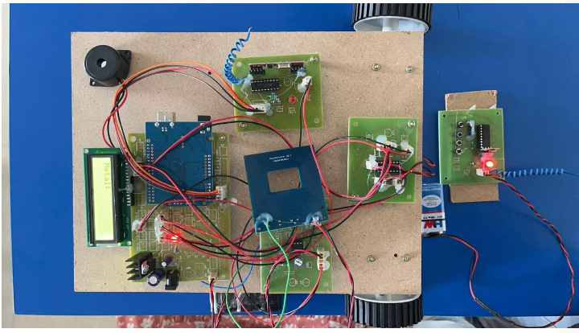

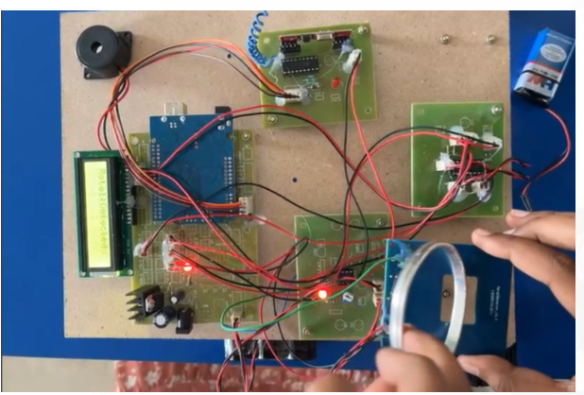

- CONCLUSION

7.CONCLUSION

Remote operated metal detecting robots represent a substantial advancement in the field of metal detection, offering enhanced safety, efficiency, and accuracy. The integration of high-sensitivity sensors, advanced signal processing, and robust mobility allows these robots to effectively detect metal objects in various environments and terrains. The user-friendly remote control interface and reliable real-time communication enhance operational efficiency and ensure the operator's safety by enabling control from a safe distance. Experimental investigations have demonstrated the robot's capability to navigate diverse terrains and accurately identify buried metal objects, confirming its practical utility in applications such as archaeology, security, and landmine detection. Furthermore, the modular design facilitates easy customization and upgrades, increasing the robot's versatility and adaptability to different tasks. Overall, the remote operated metal detecting robot is a powerful tool that significantly improves the processes of metal detection, providing substantial benefits across multiple industries.

- REFERENCES

8.REFERENCES

- M. Heidi, (1999) “Bluetooth technology and Implementations”, John
Wiley & Sons.
- Piyare, R. and Tazil, M. (2011) “Bluetooth based home automation
system using Android phones”. IEEE 15TH International symposium
on consumer electronics (ISCE), 14-17 June 2011, Singapore.
- Potts, J. and Sukittanon, S. (2012) “Exploiting Bluetooth on android
mobile devices for home security application”, proceedings of
southeastcan, 15-18 March 2012, Orlando, Florida, USA.
- HC-06 Bluetooth module.

